Being Pythagoras for a Day
Activity A
For this activity, you will need to work with a partner. Instructions and Items needed go here.

- On your piece of paper, draw a straight line.  (Tip: Try to keep the length of your line a whole number.)  What is the length of this line? ________ |  | 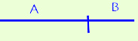  Steps 1 and 2.
- Divide the line into two, unequal line segments. On your paper, label one segment as A and the other segment as B.

What is the length of segment A? _______
What is the length of segment B? _______

- Now construct a square with side lengths A + B like in the picture below.

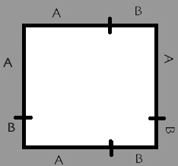
- Using a ruler, separate your large square into smaller squares and rectangles.  Describe the following in terms of A, B, and C:  Area of square 1: ____________________________  Area of rectangle 2: __________________________  Area of rectangle 3: __________________________  Area of square 4: _____________________________  What are two ways we can express the area of the entire square using A, B, and C?  _________________________________________________ | 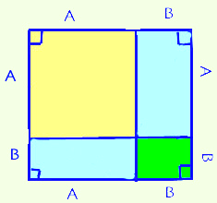  1  2  4  3  Step 4.
- Draw the diagonals of rectangles 2 and 3. Label the diagonals as C.  What is the length of C? ___________  - Using your pair of scissors, cut out the four triangles you just made by drawing the diagonal C. | 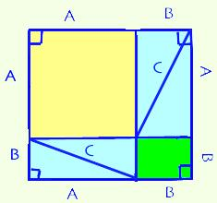  Steps 5 and 6.  The “old square”.
- Arrange the four triangles into the shape of a new square that leaves a hole in the center.  In terms of A, B, and C, what is the area of the hole in the center?  ___________________  What is the area of the “new square”, including the hole in the center? (Hint: You have already found the area of all the triangles. Use what you know.)  _____________________________________ | 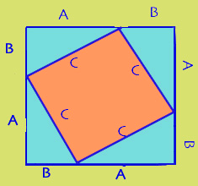  Step 7.  The “new square”.  The shaded region is empty.
If you added the area of the hole in the center with the area of the four triangles, would this new square’s area be:
- Larger than the “old square’s” area
- Equal to the “old square’s” area
- Less than the “old square’s” area

How did you come to your conclusion?

__________________________________________________________________________________________________________________

Despite what you may have answered previously, assume for now that the “old square’s” area is equal to the “new square’s” area.
Write the “old square’s” area equal to the “new square’s” area.

__________________________________ = ________________________________________

Simplify the above equation. (Hint: Try to get either A, B, or C completely by itself.)

_________________________________ = _________________

Test the validity of the above equation by plugging in the side lengths for A, B, and C you found in Step 2 and Step 5. Show your work below.

